When you initially open the webpage ,a prompt is displayed asking for transaction amount that will be inserted in block 4 ,index “e”:

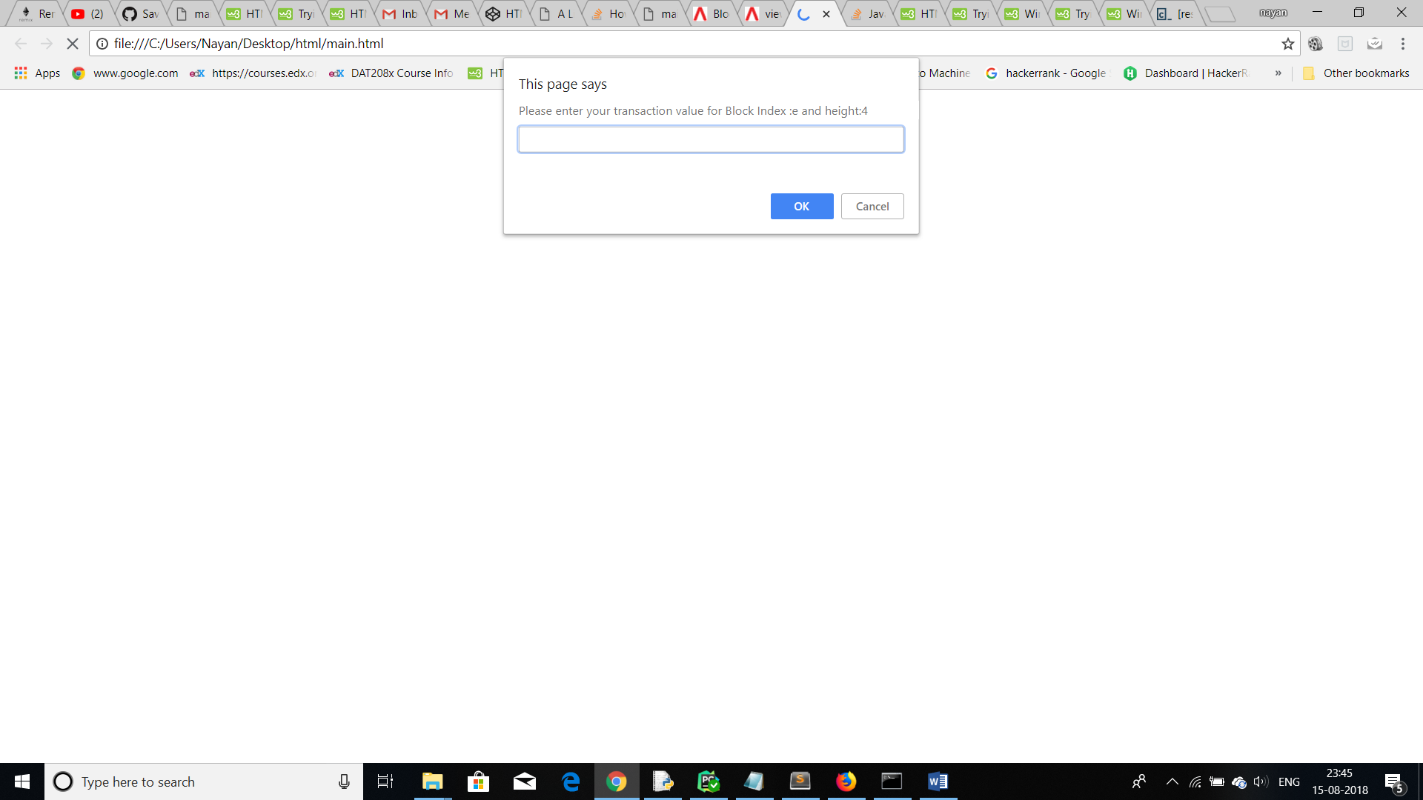

These are the genesis and the first 3 predefined blocks for the purpose of display :

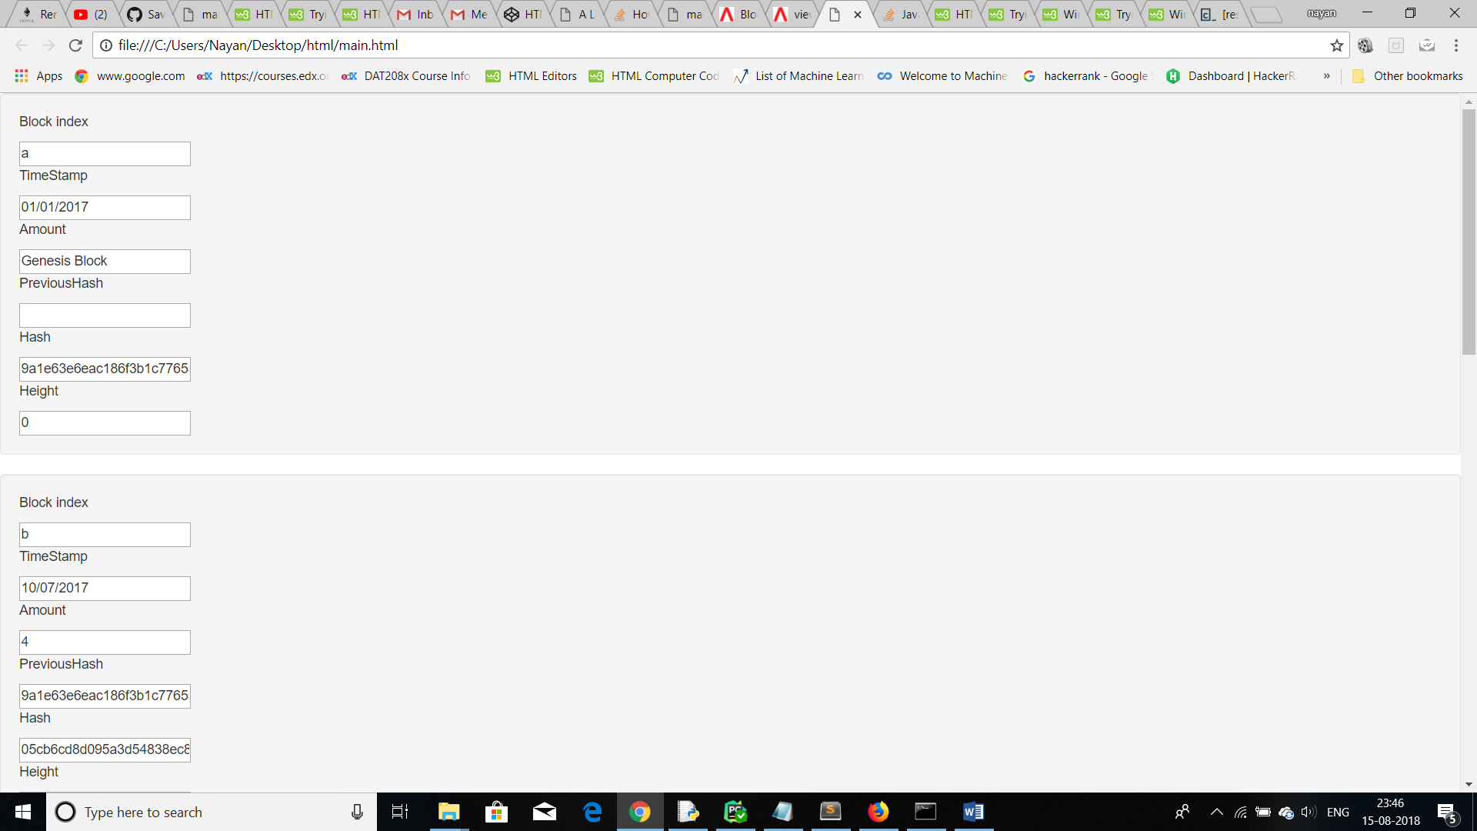

234 was inserted in the prompt for transaction which is added to the chain:

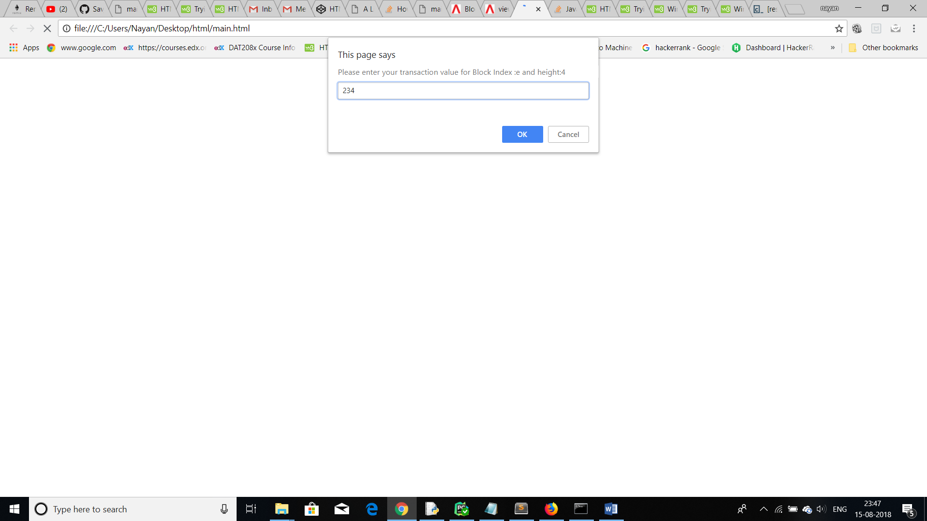

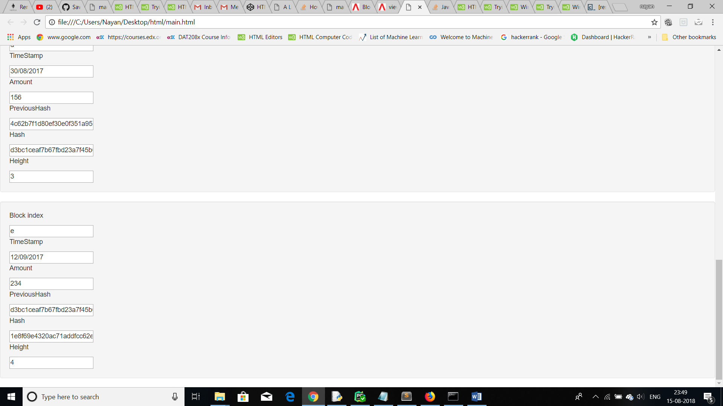

Time Taken to develop the blockhain: 4.5 hours